**BDM 1034 - Application Design for Big Data**

**SQL Essential Training**

**Submitted by: Aadarsha Chapagain**

**Student ID:C0825975**

**Submitted to: Prof. Teresa Zhu**

Here I have attached the certificate I achieved from Linkedin learning for Course “**SQL Essential Training** along with the Screenshot of queries I practised”

**Insert Query:**

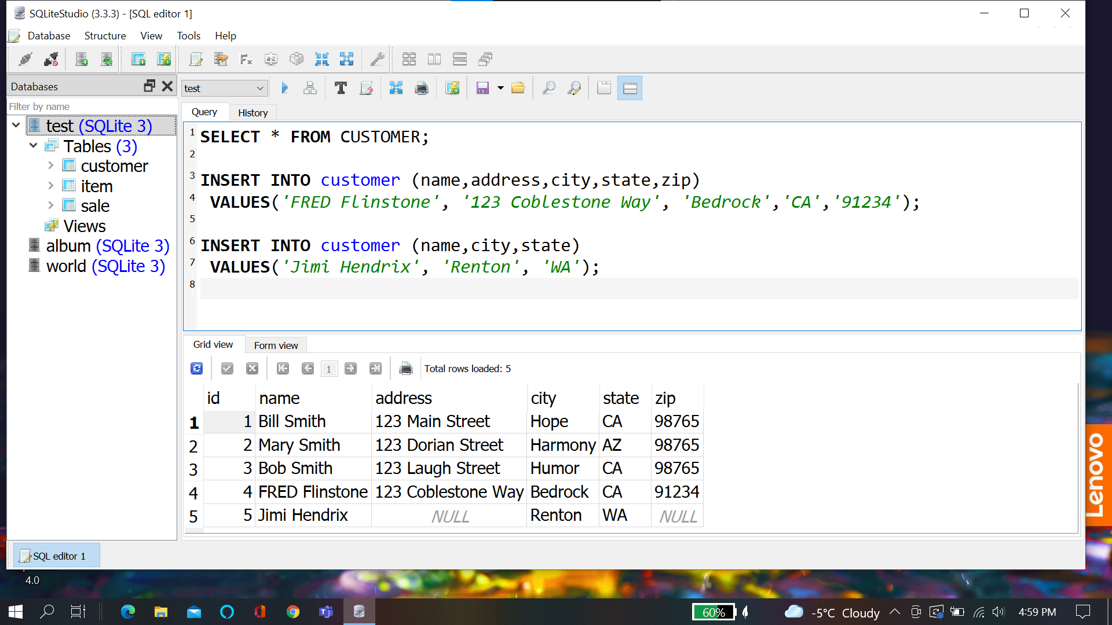

**Update Query:**

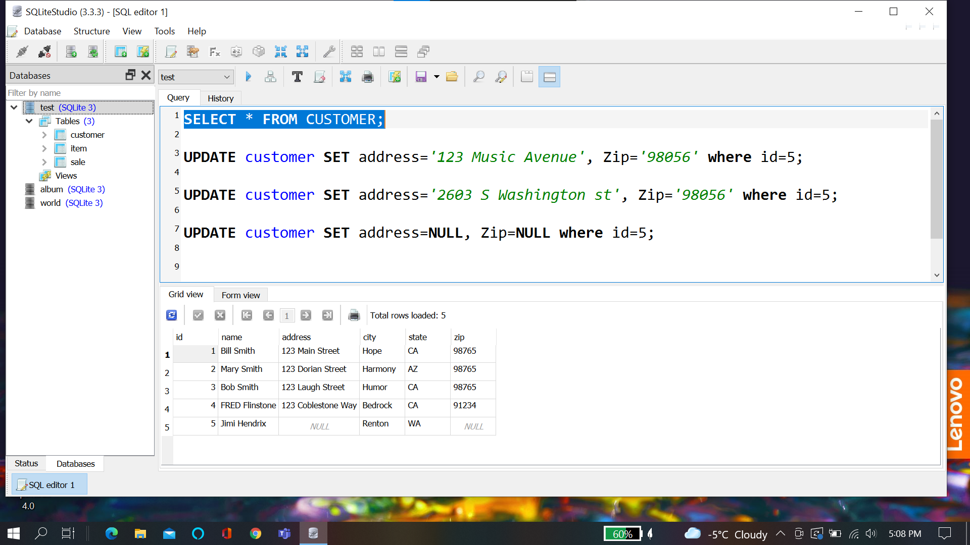

**Delete Query:**

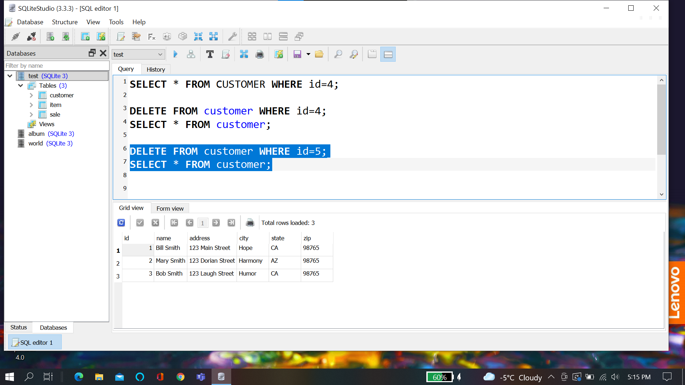

**Chapter Quiz 1:**

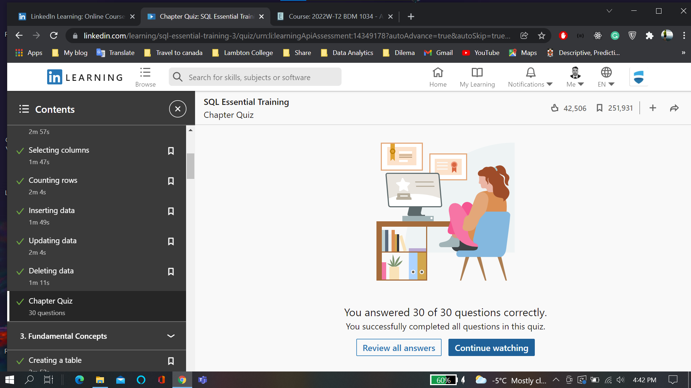

**Fundamental Concepts:**

**Creating a table:**

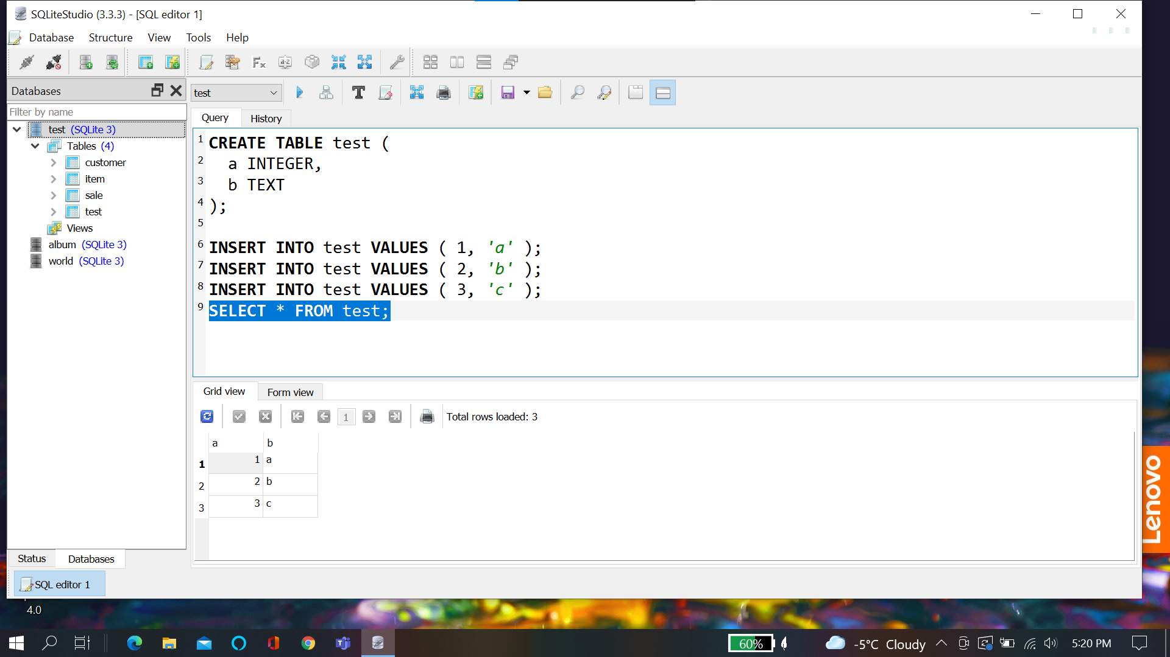

**Drop Table:**

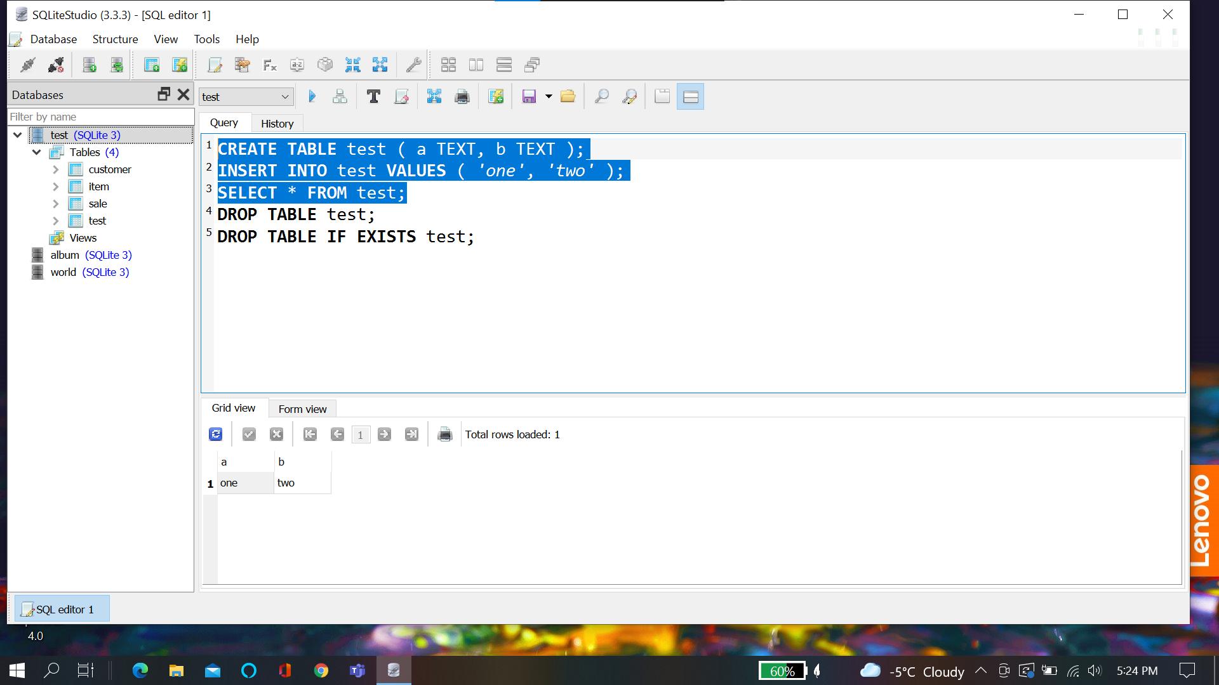

**Insert into:**

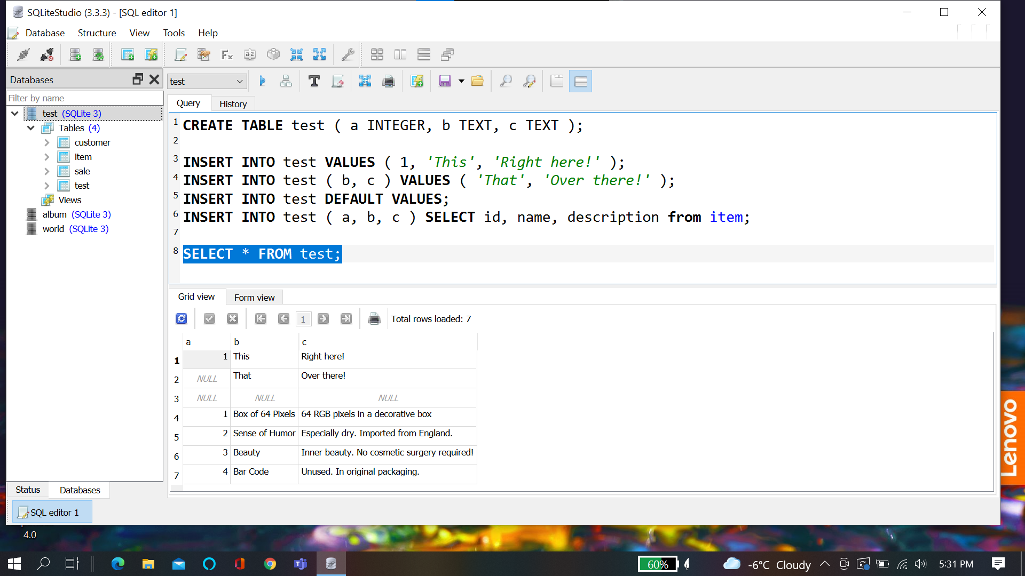

**Delete From:**

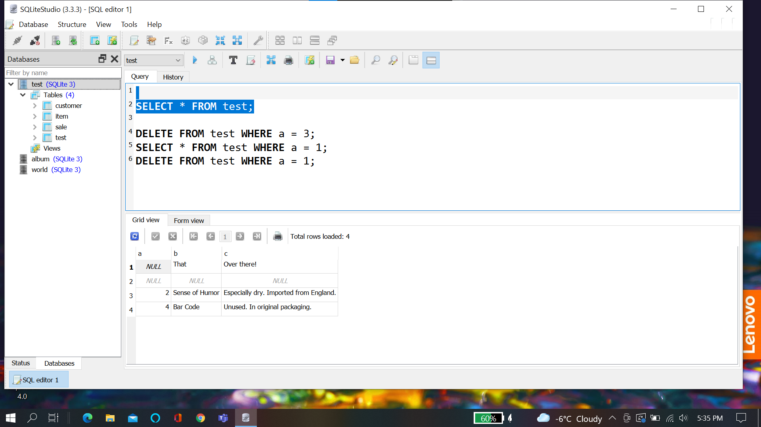

**Null**

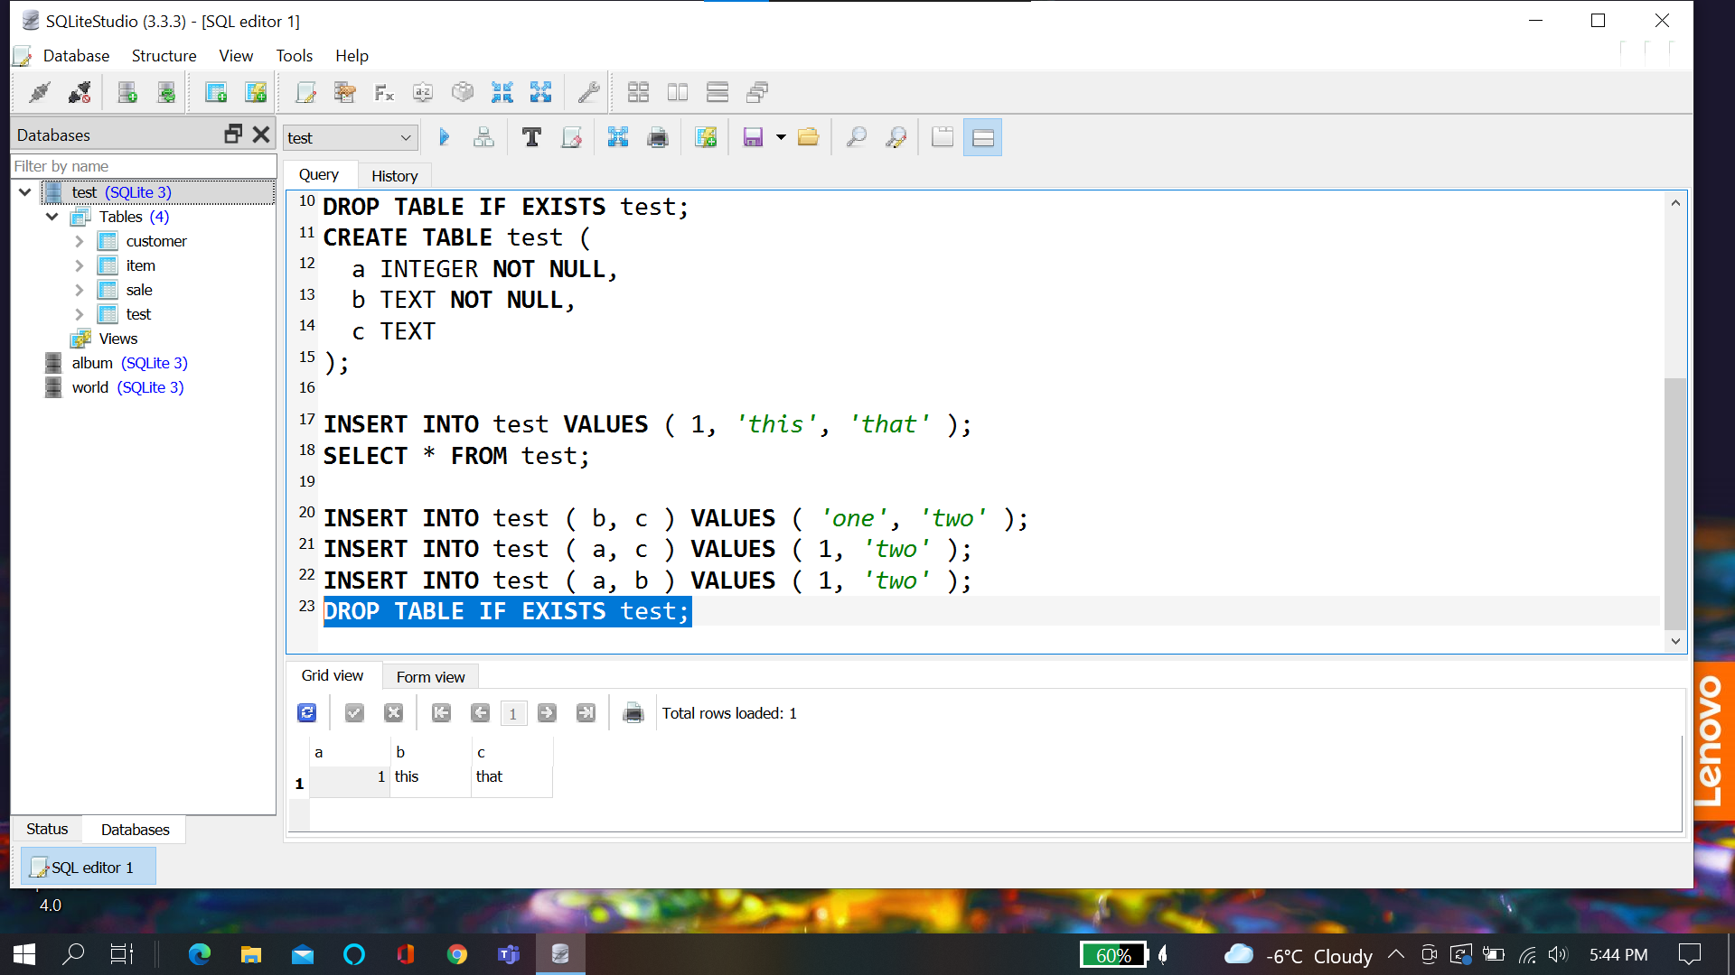

**Constraints:**

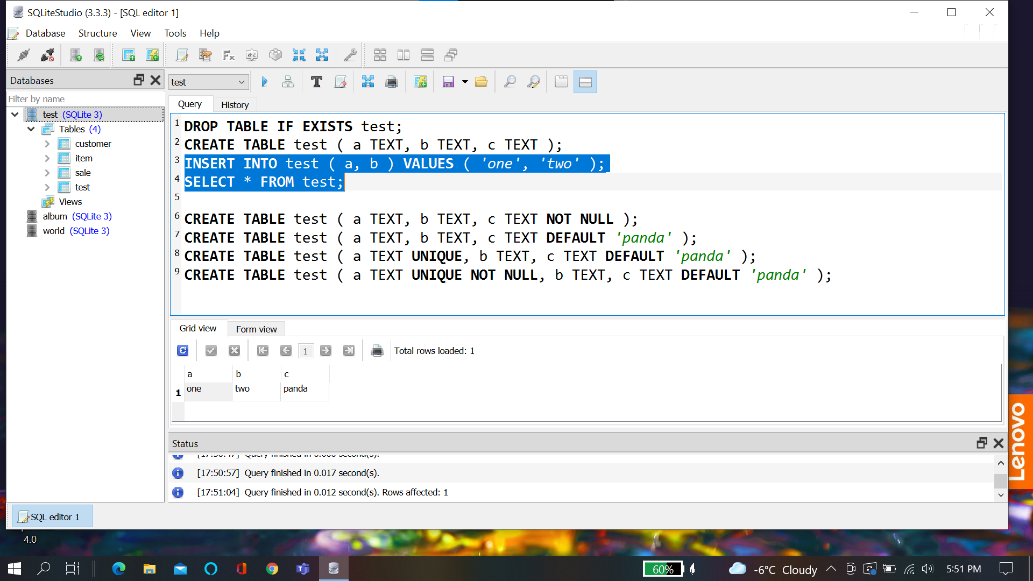

**Alter table:**

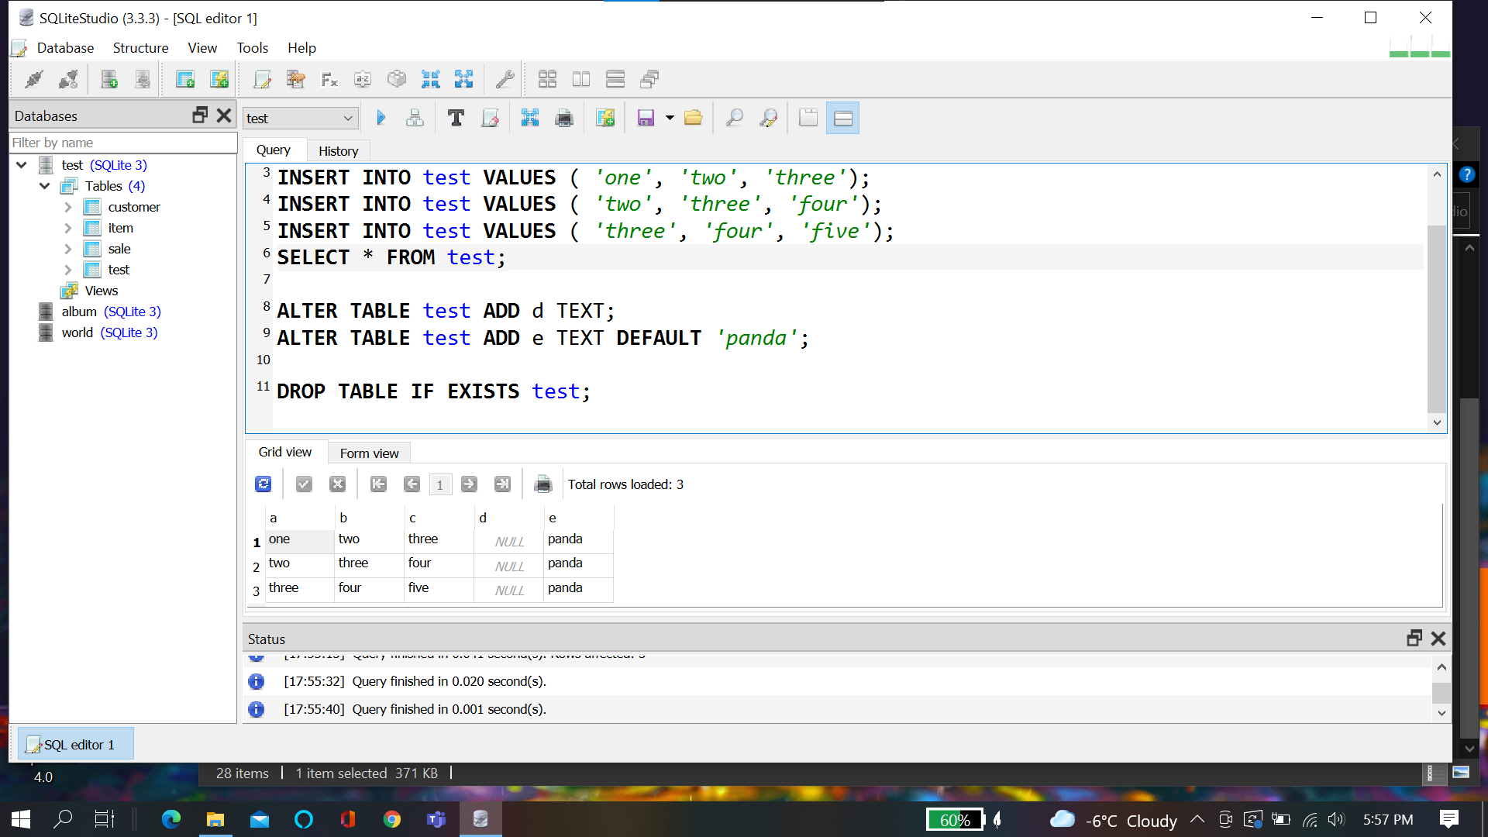

**ID:**

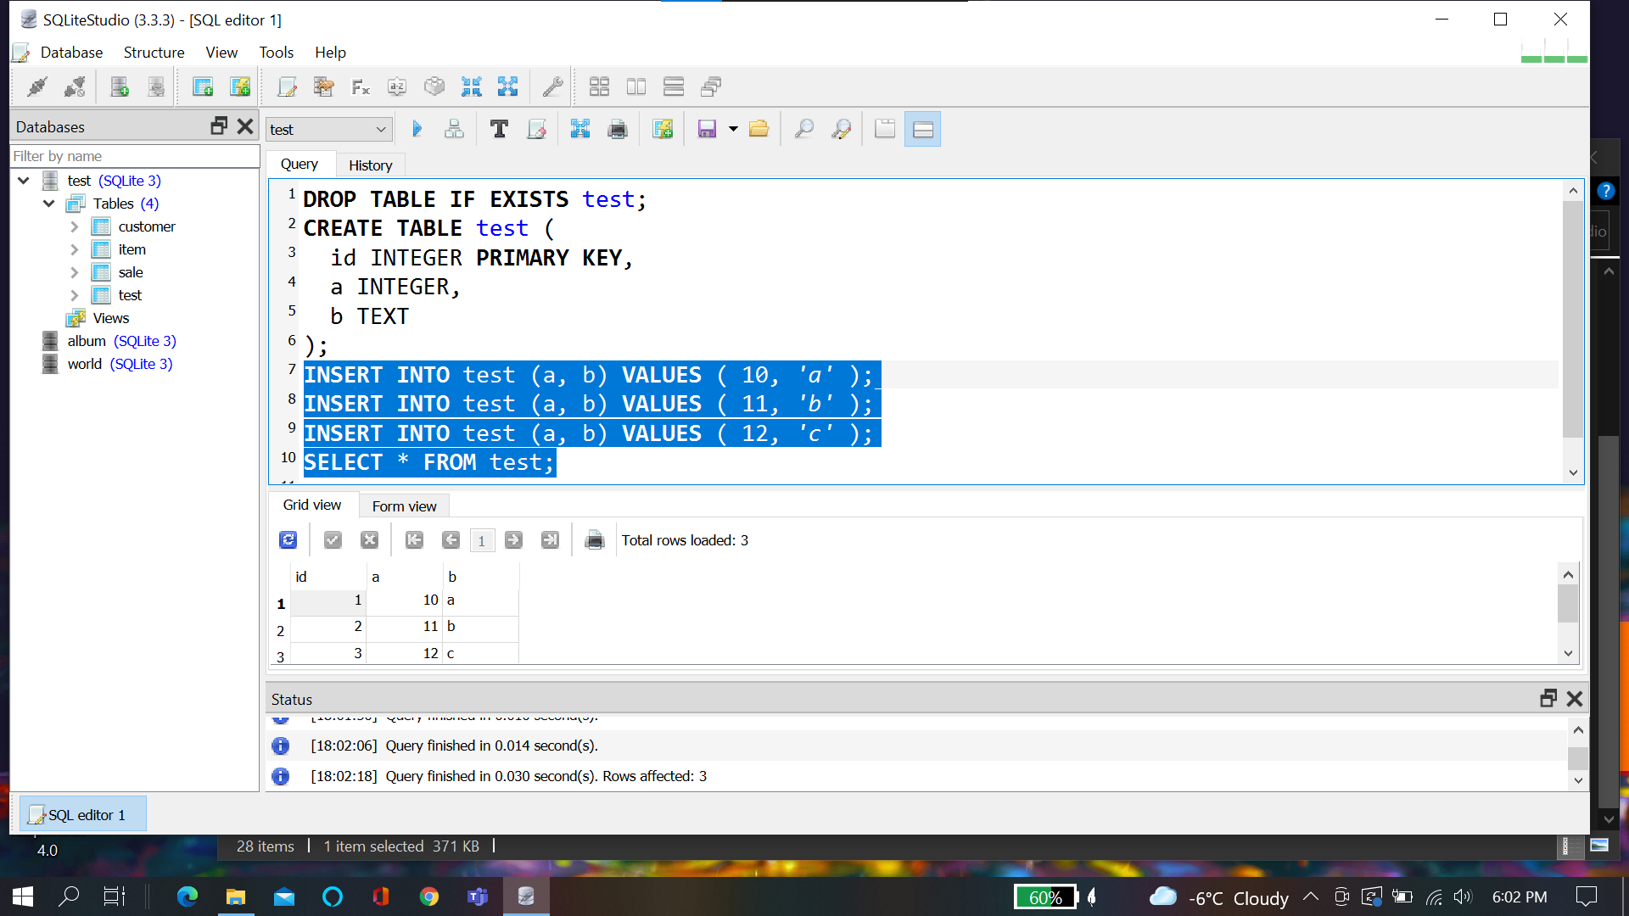

**Filtering with where like, in**

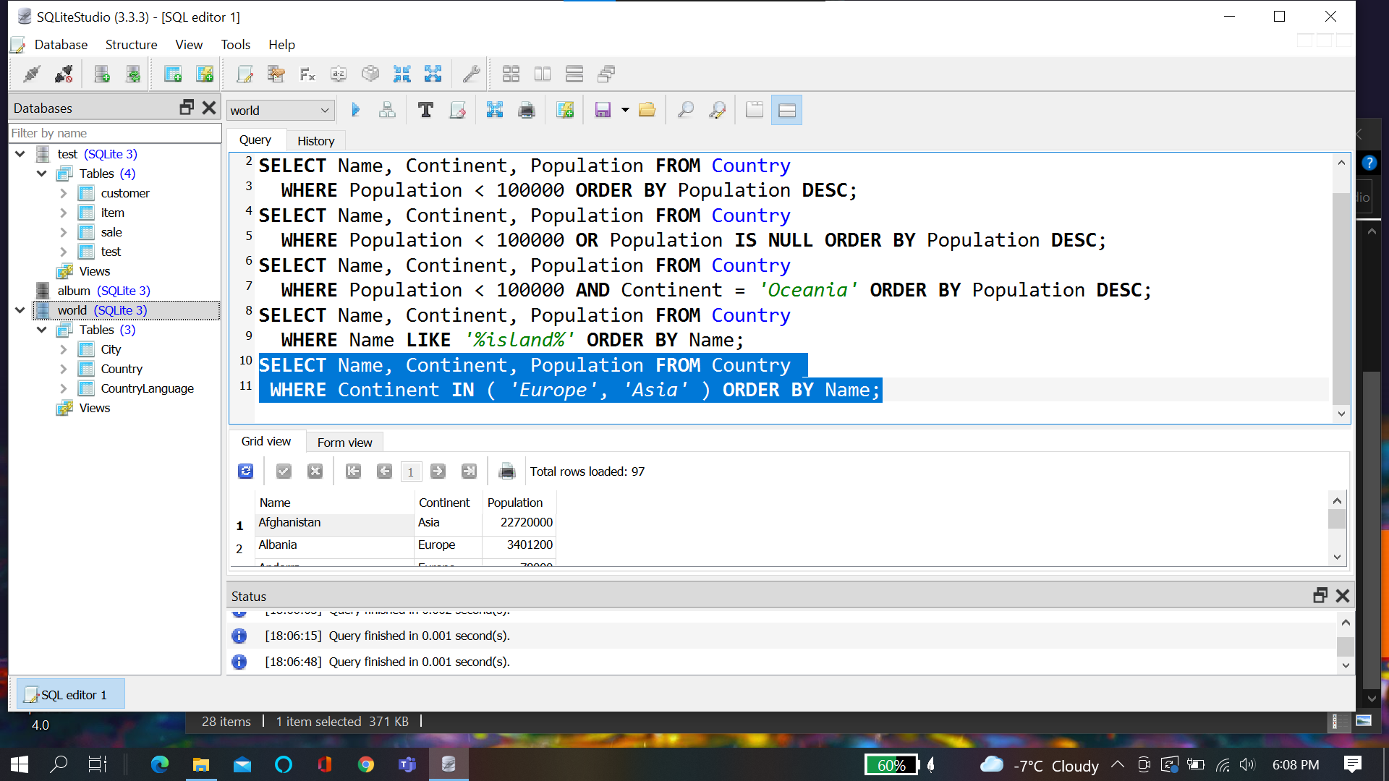

**Select Distinct:**

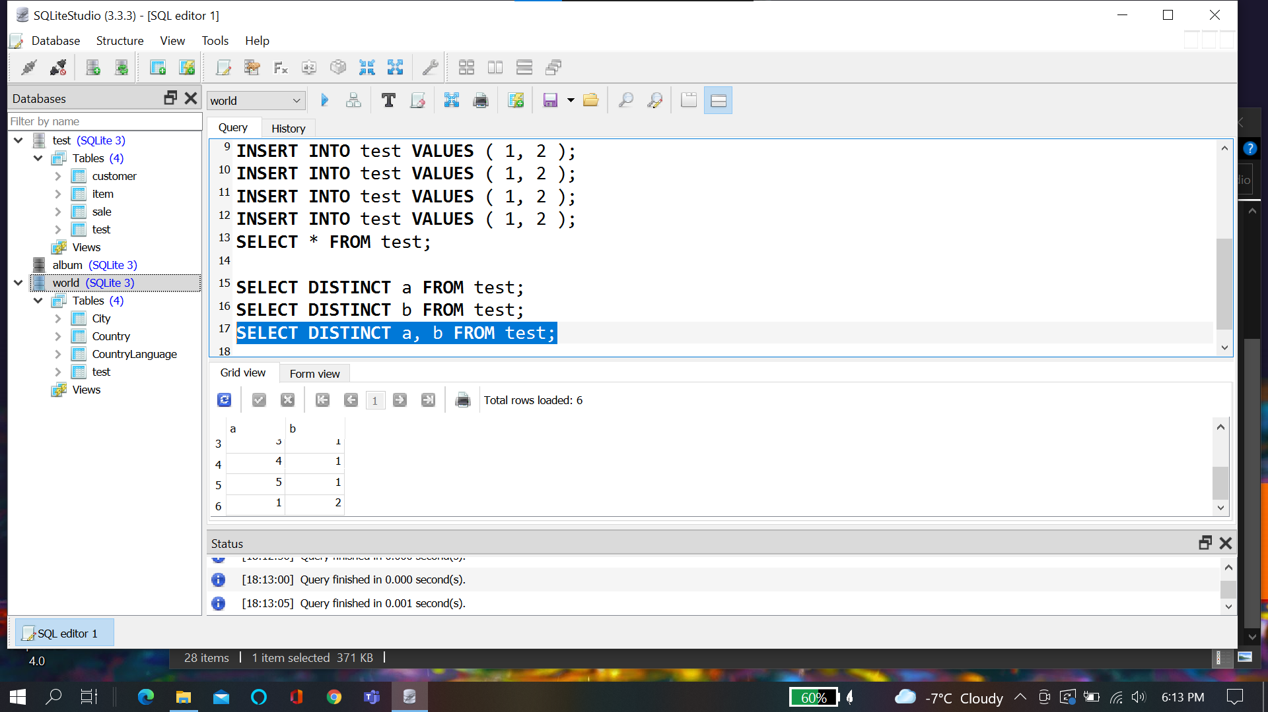

**Order By:**

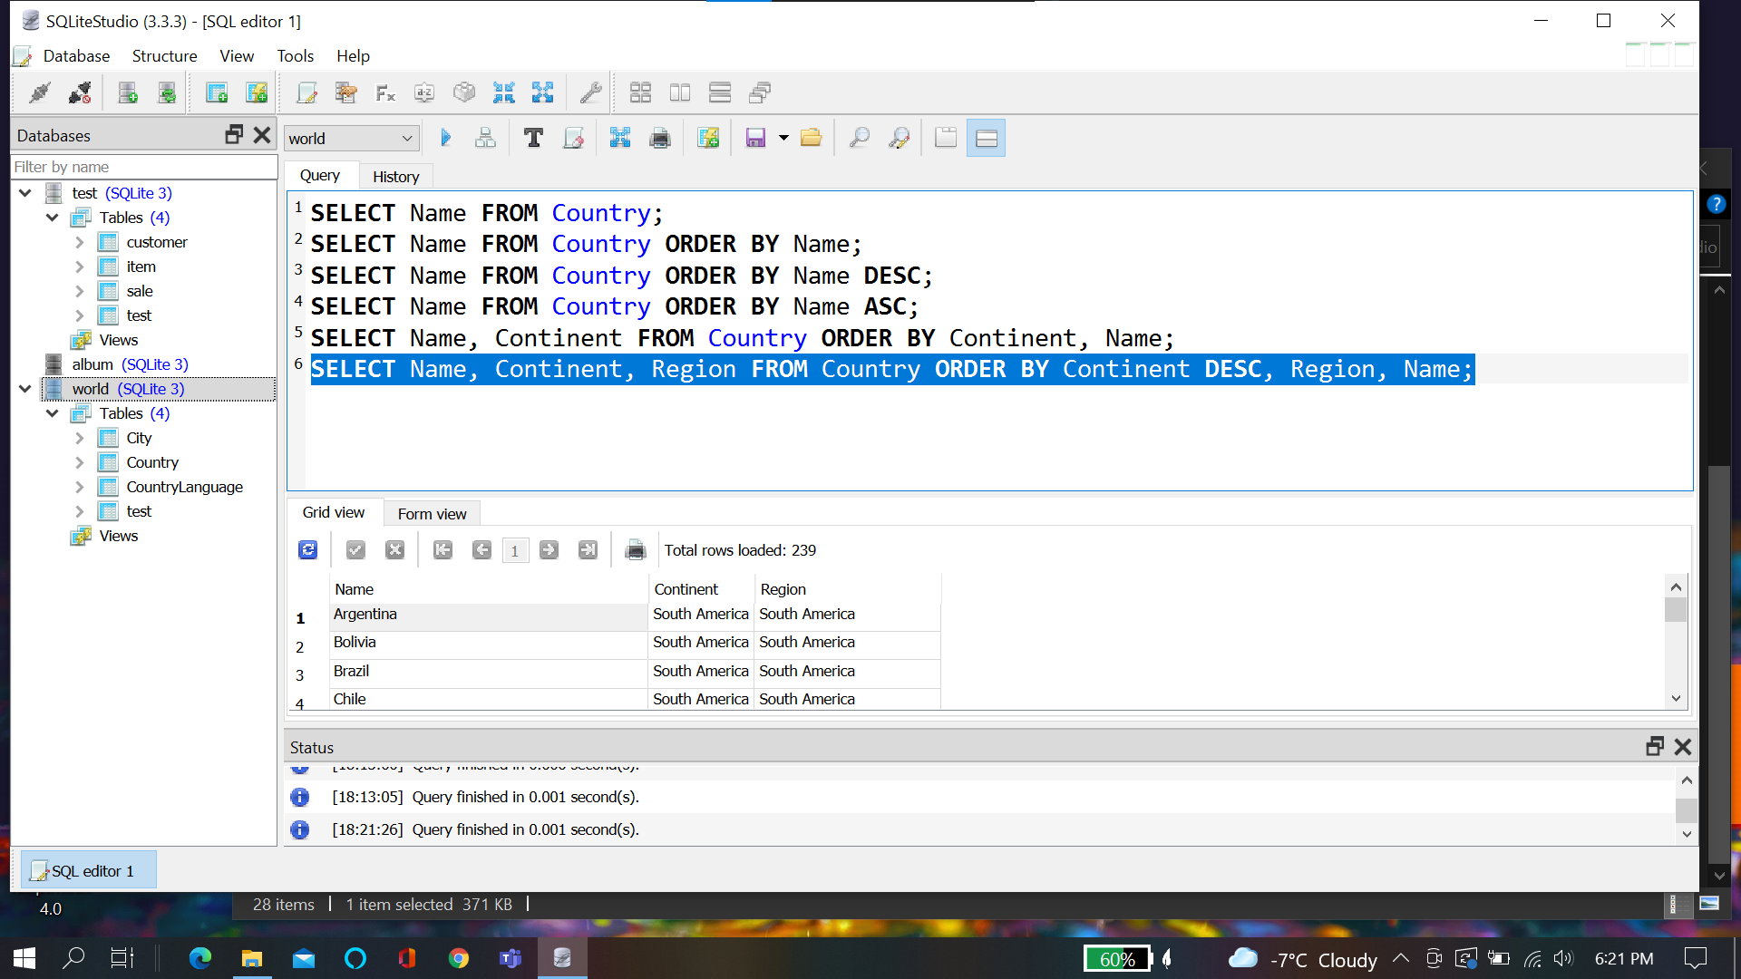

**Case:**

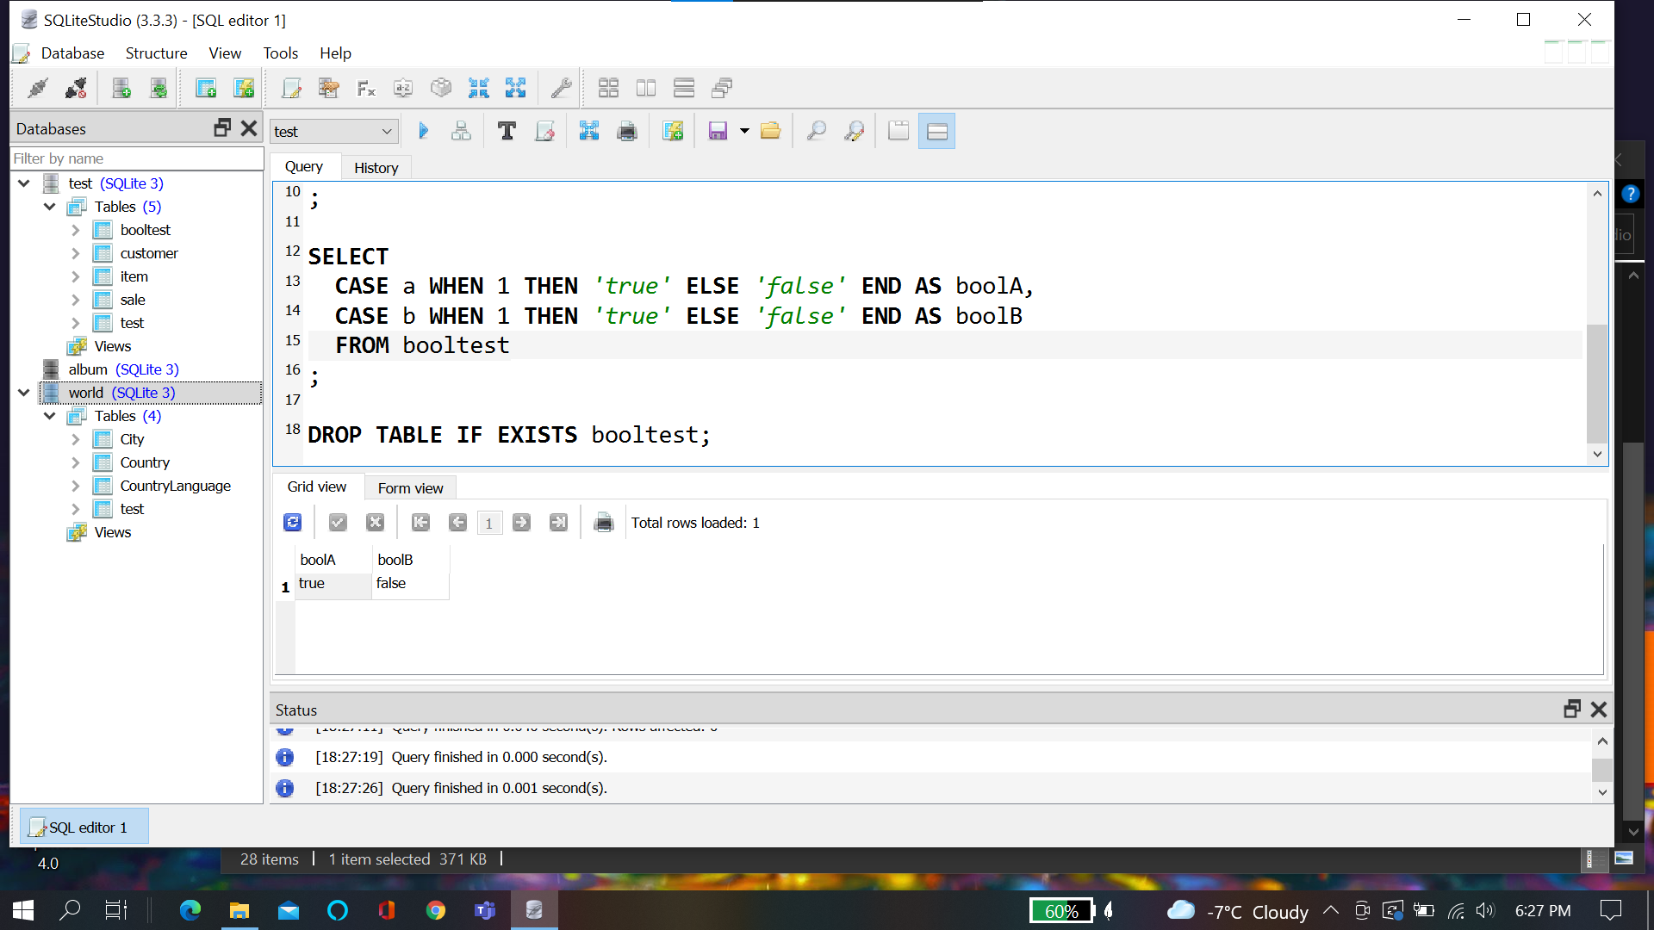

**Chapter Quiz:**

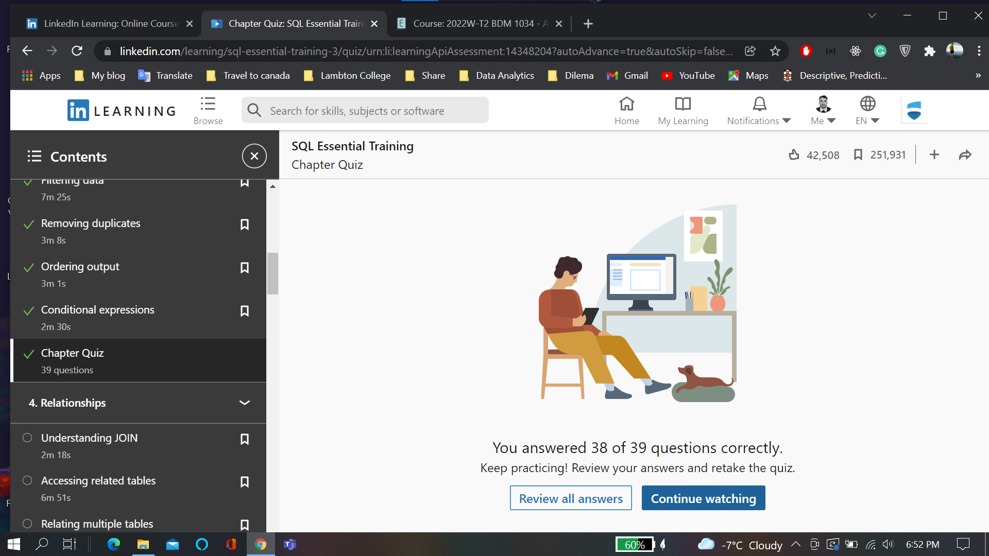

**Related Table:**

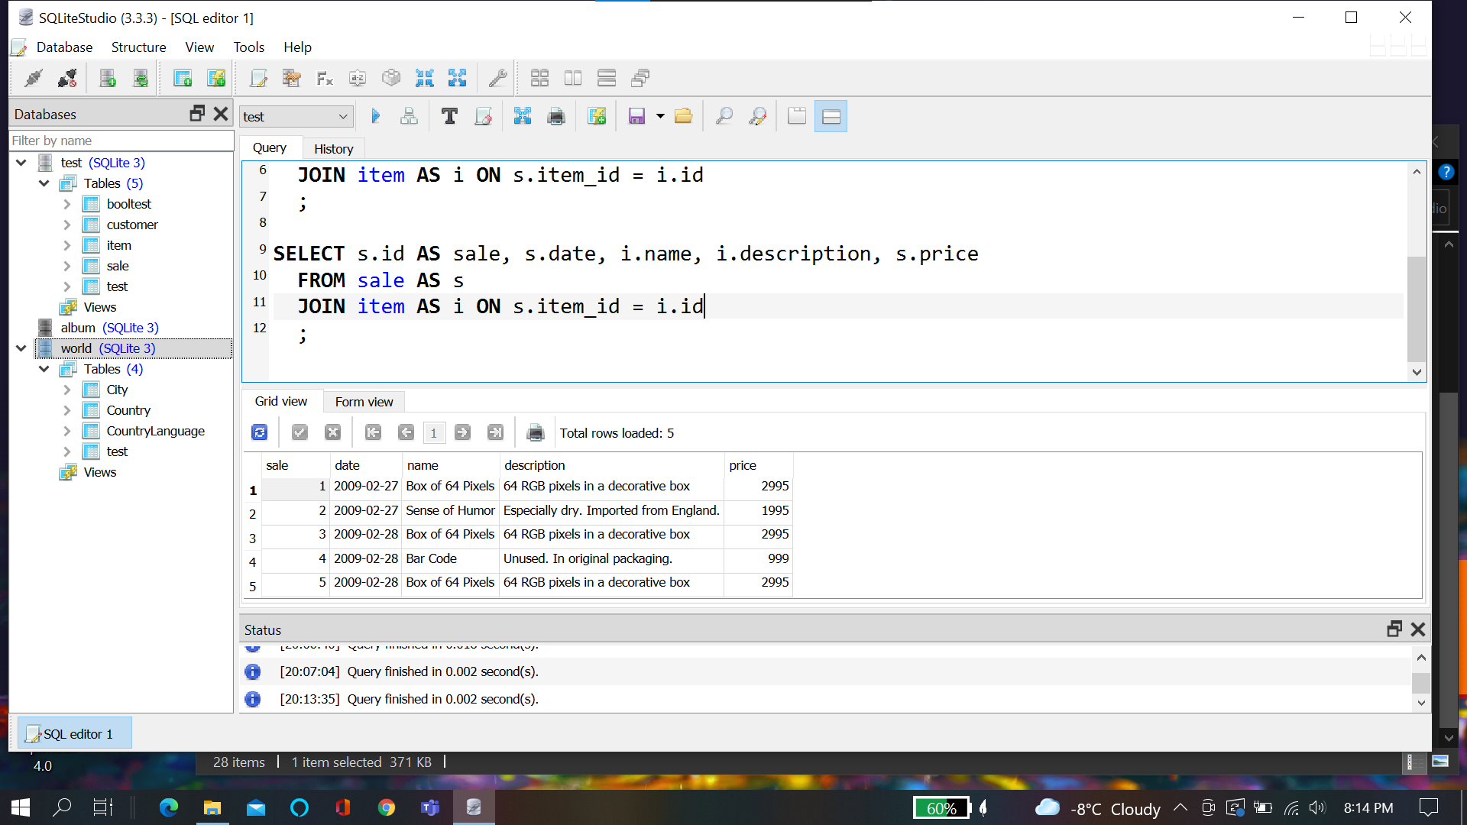

**Relating Multiple Tables**

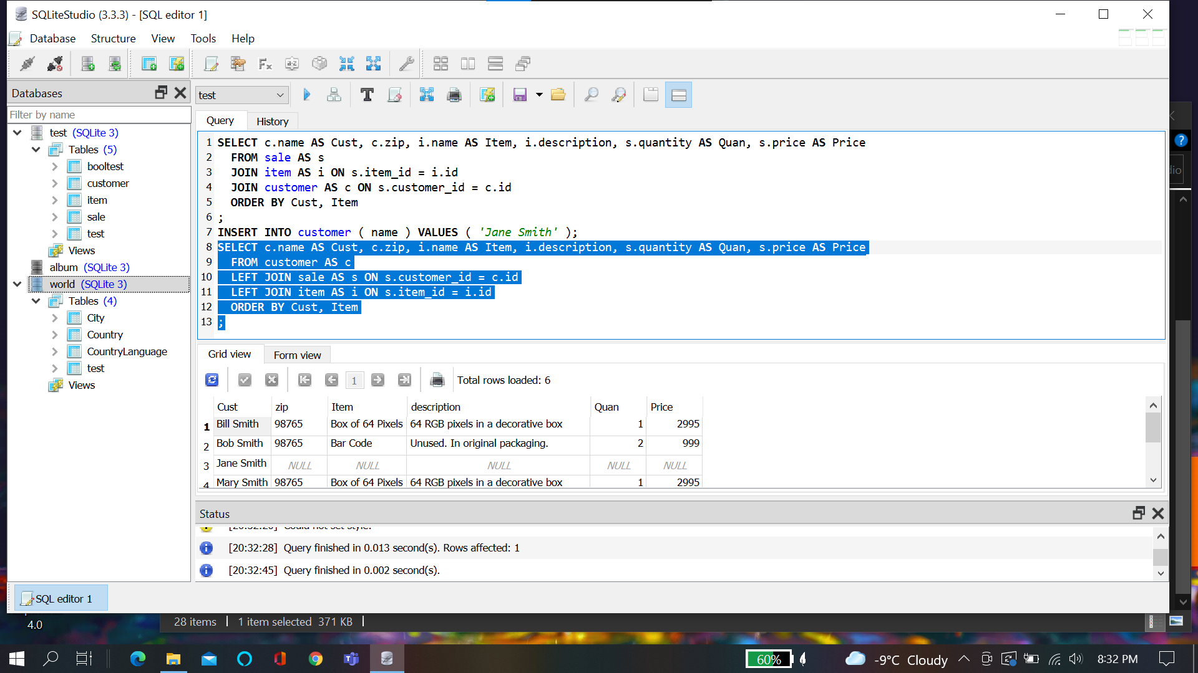

**Chapter Quiz:**

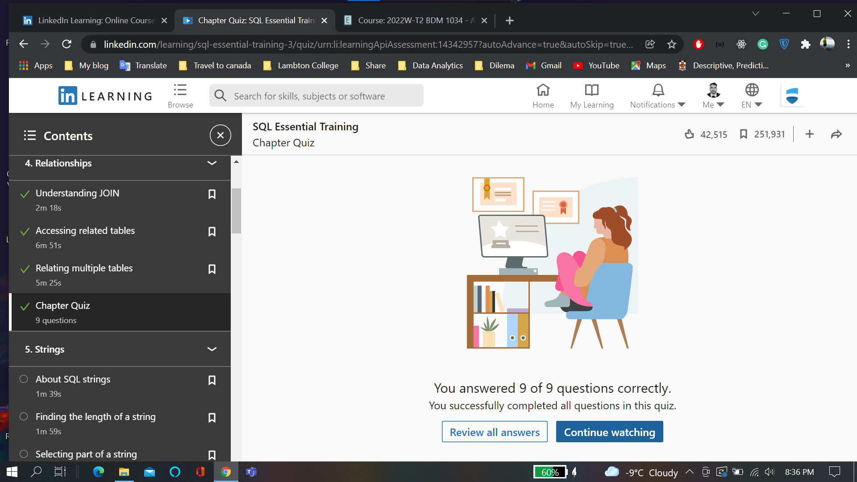

**String:**

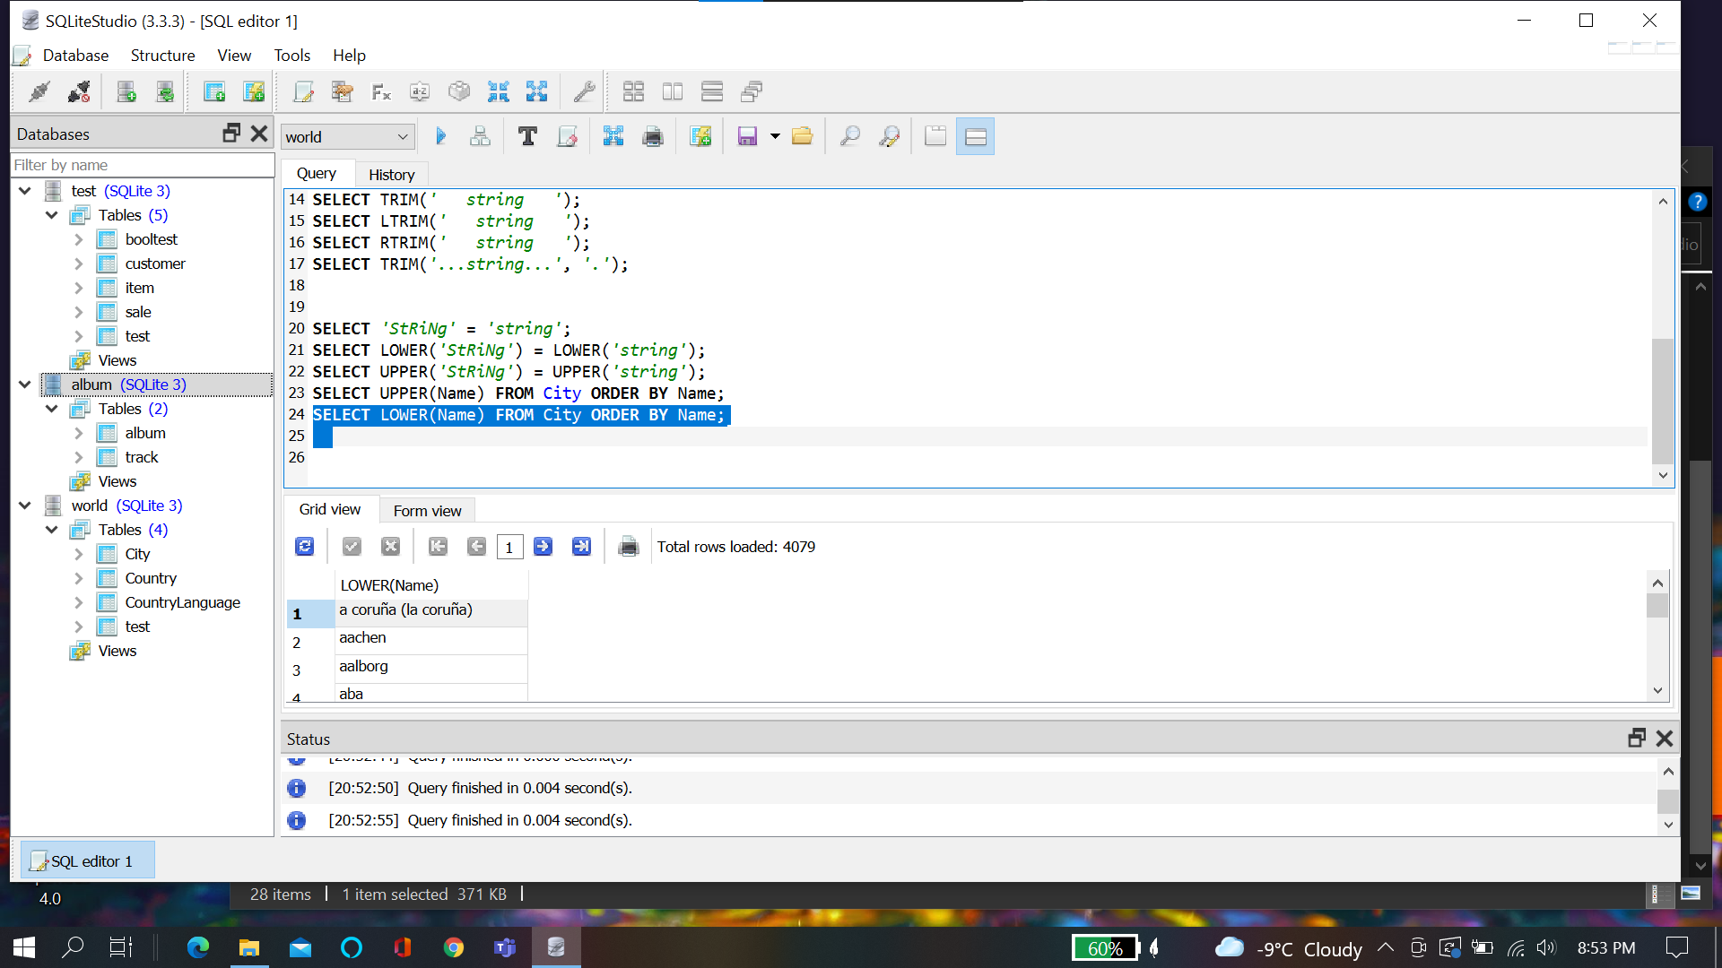

**Chapter Quiz:**

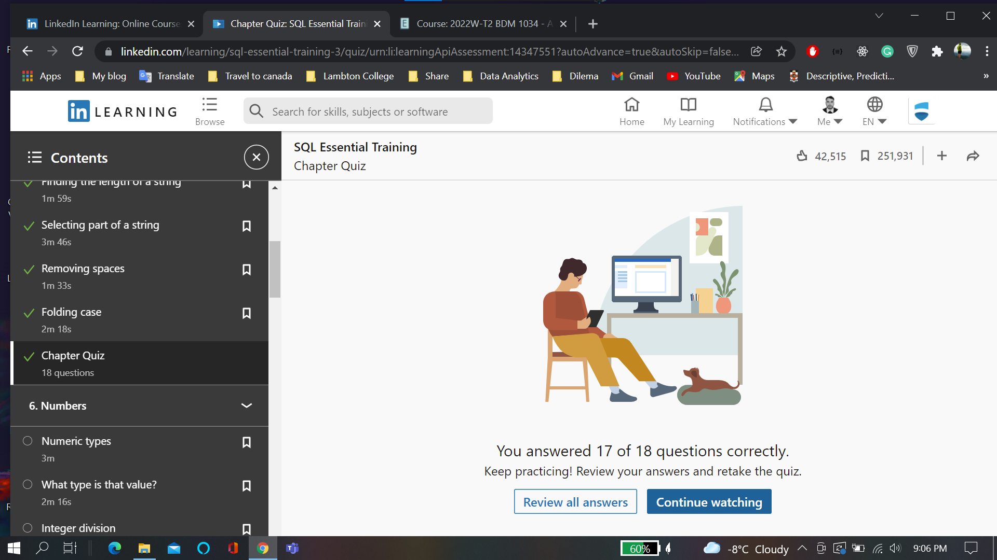

**Rounding Numbers:**

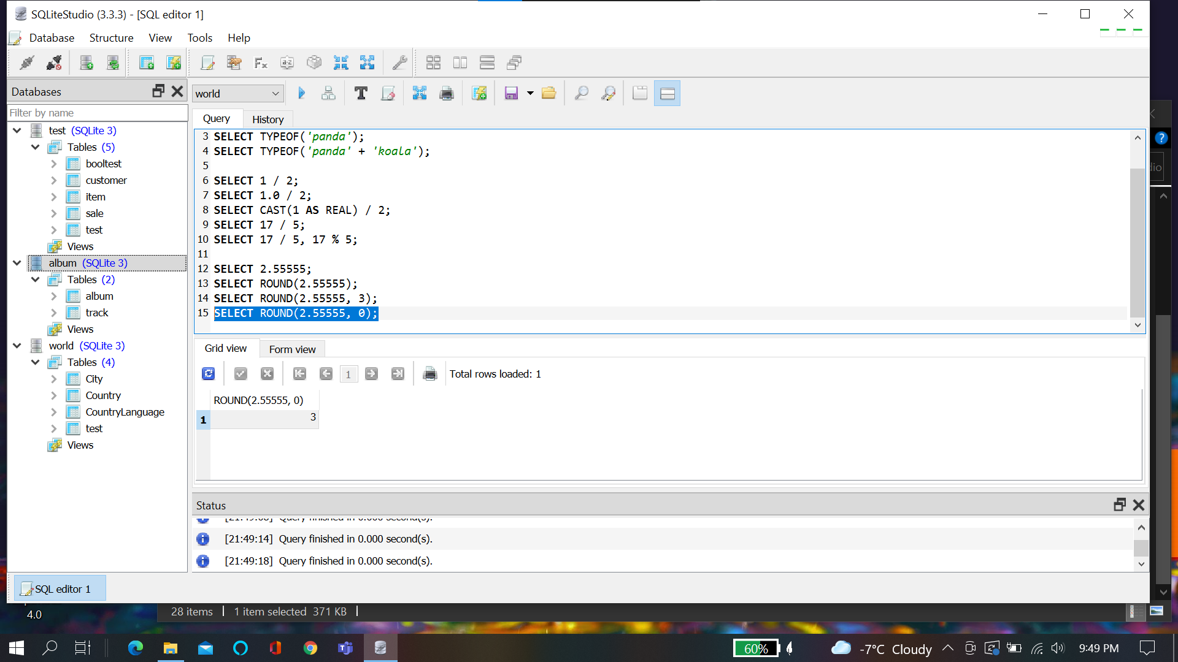

**Chapter Quiz**

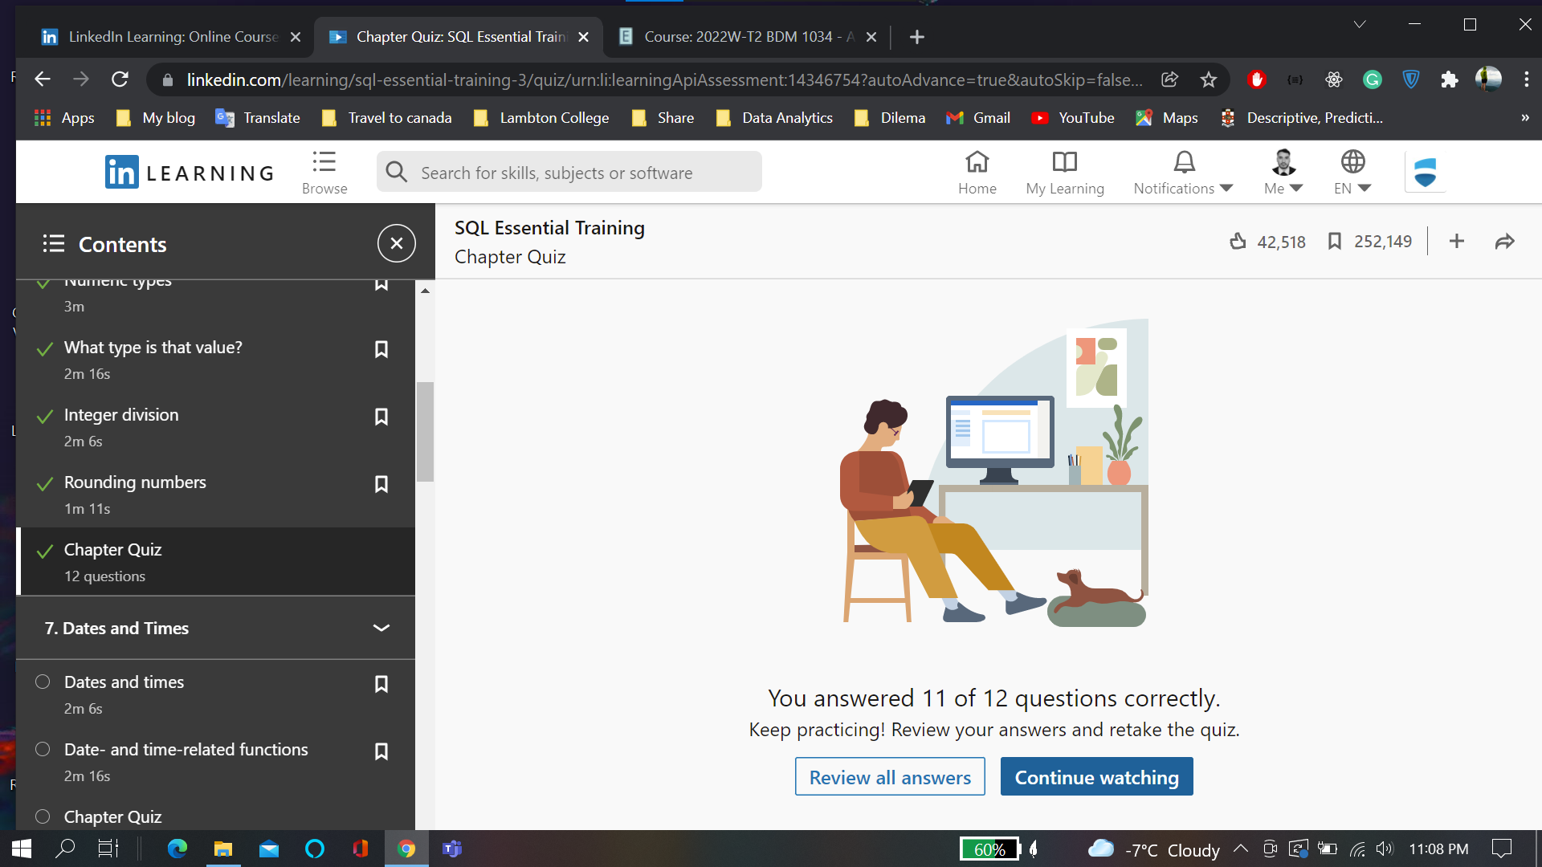

**Dates and time:**

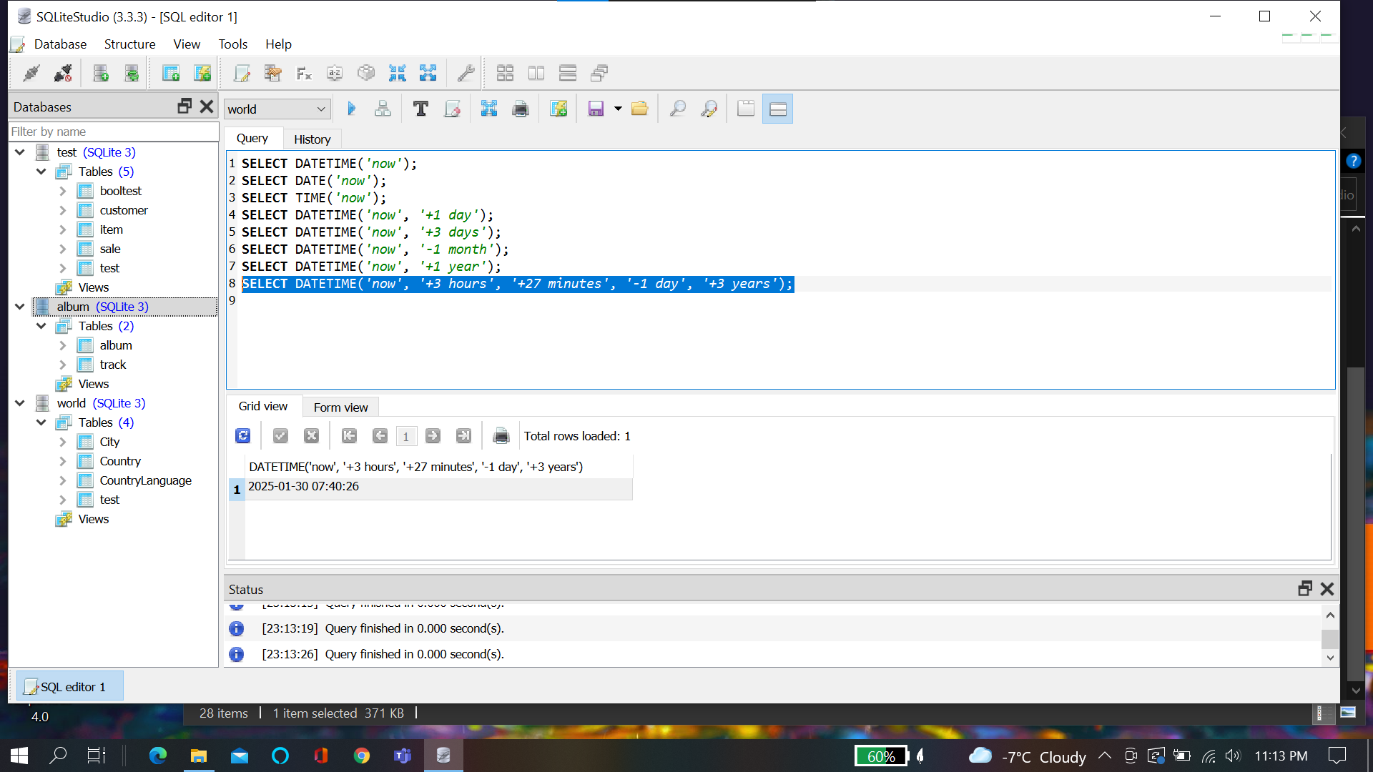

**Chapter quiz:**

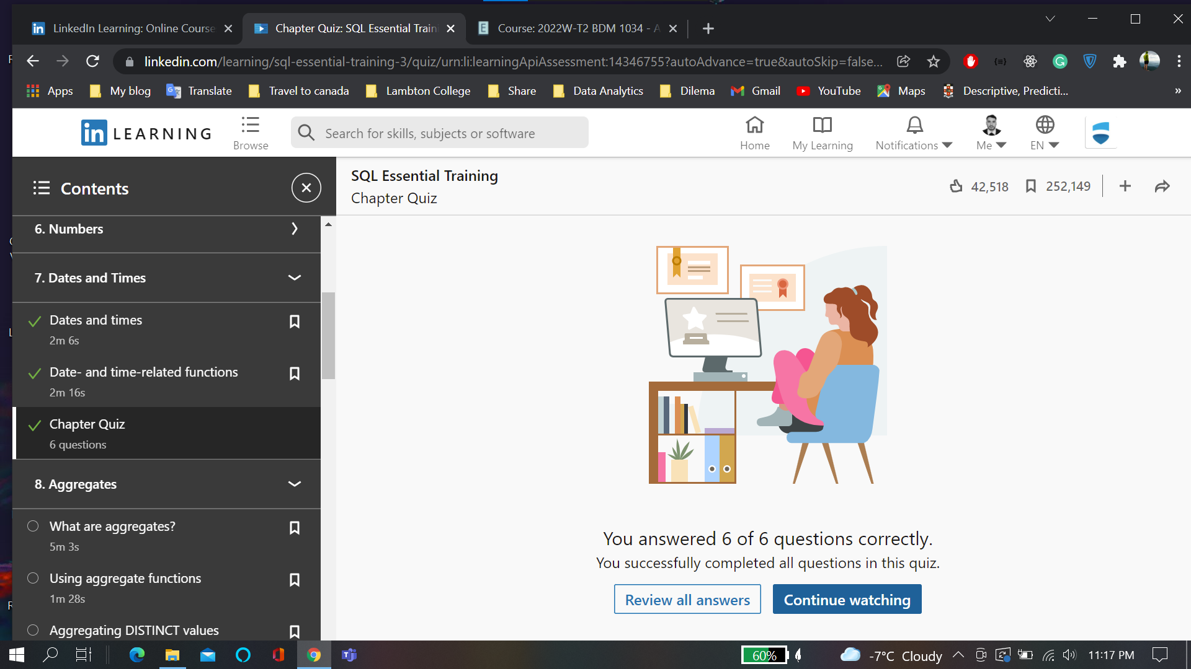

**Aggregates:**

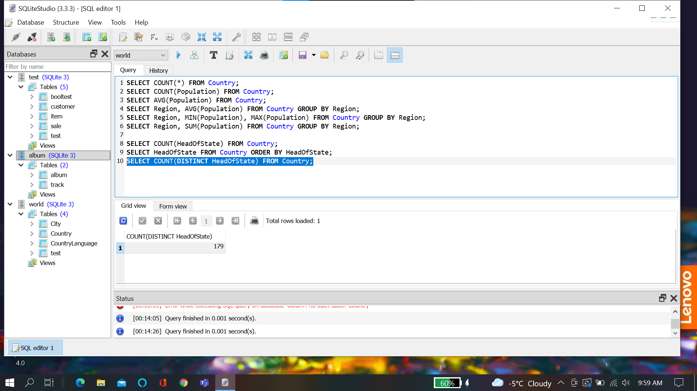

**Chapter Quiz:**

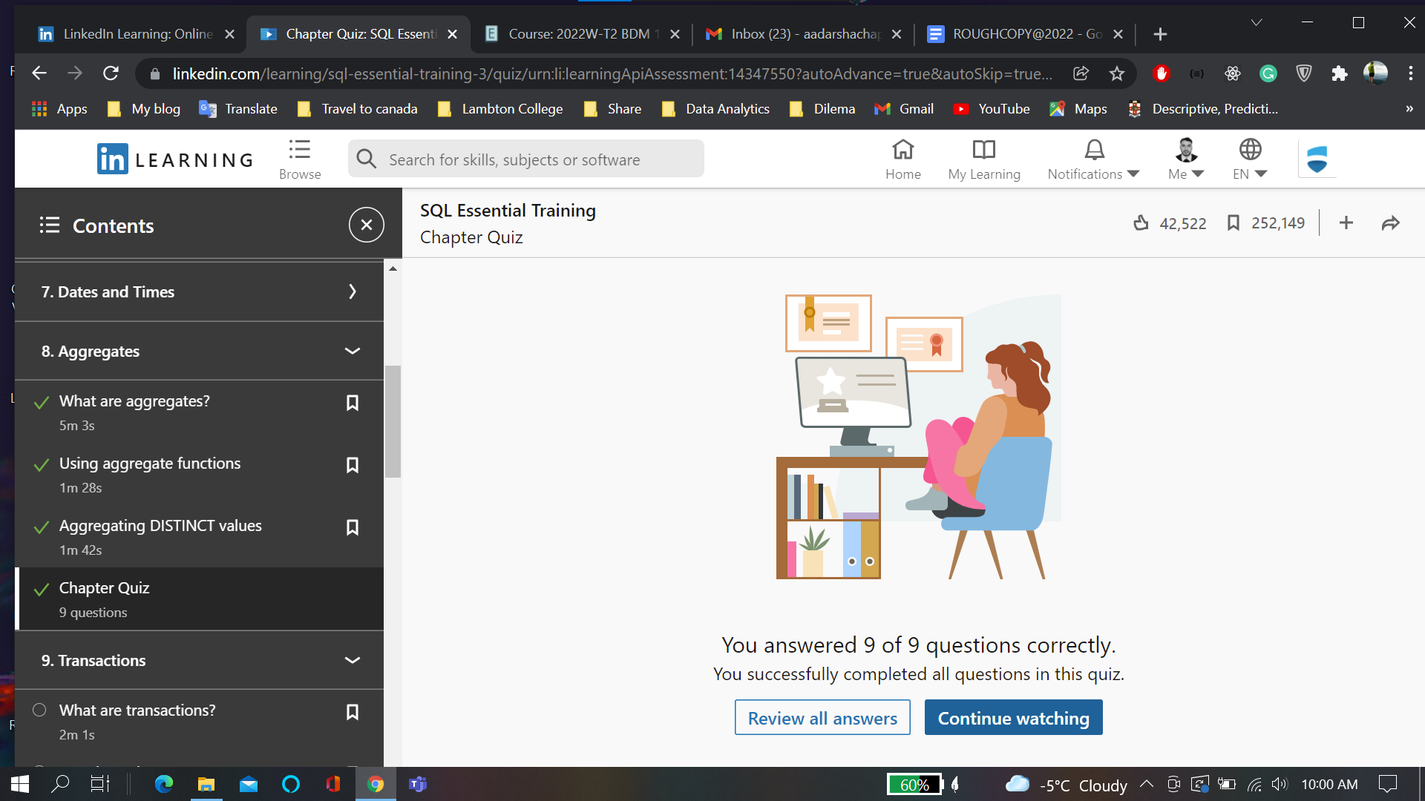

**Transactions:**

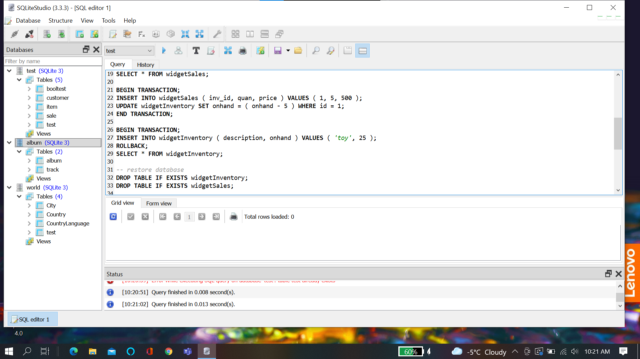

**Chapter Quiz:**

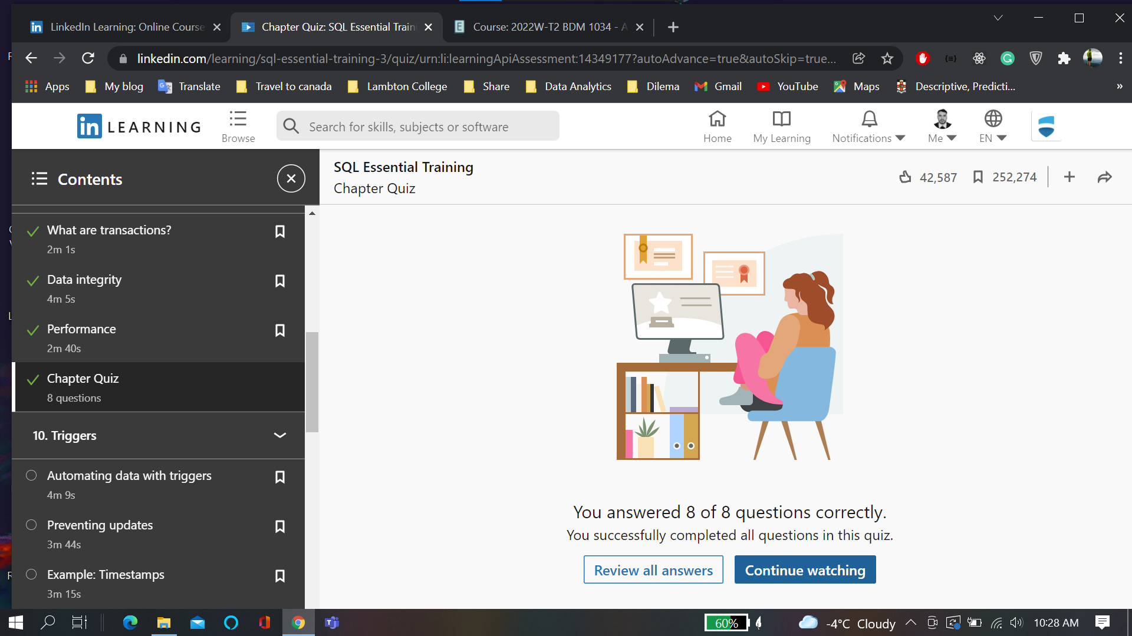

**Triggers:**

**Preventing Updates:**

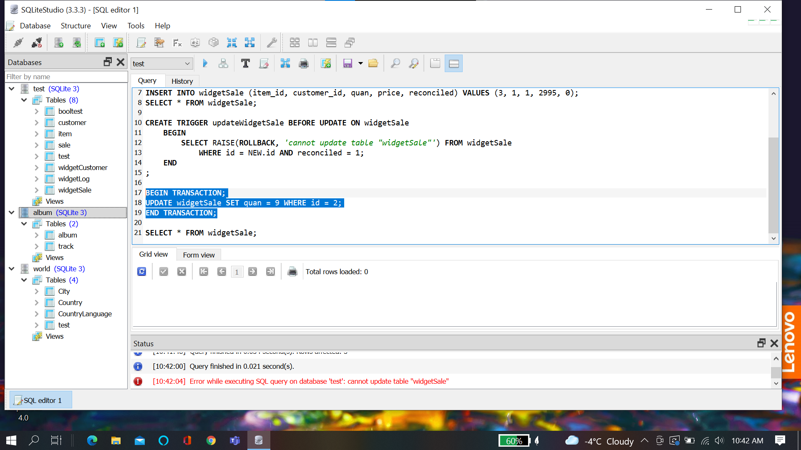

**Timestamps:**

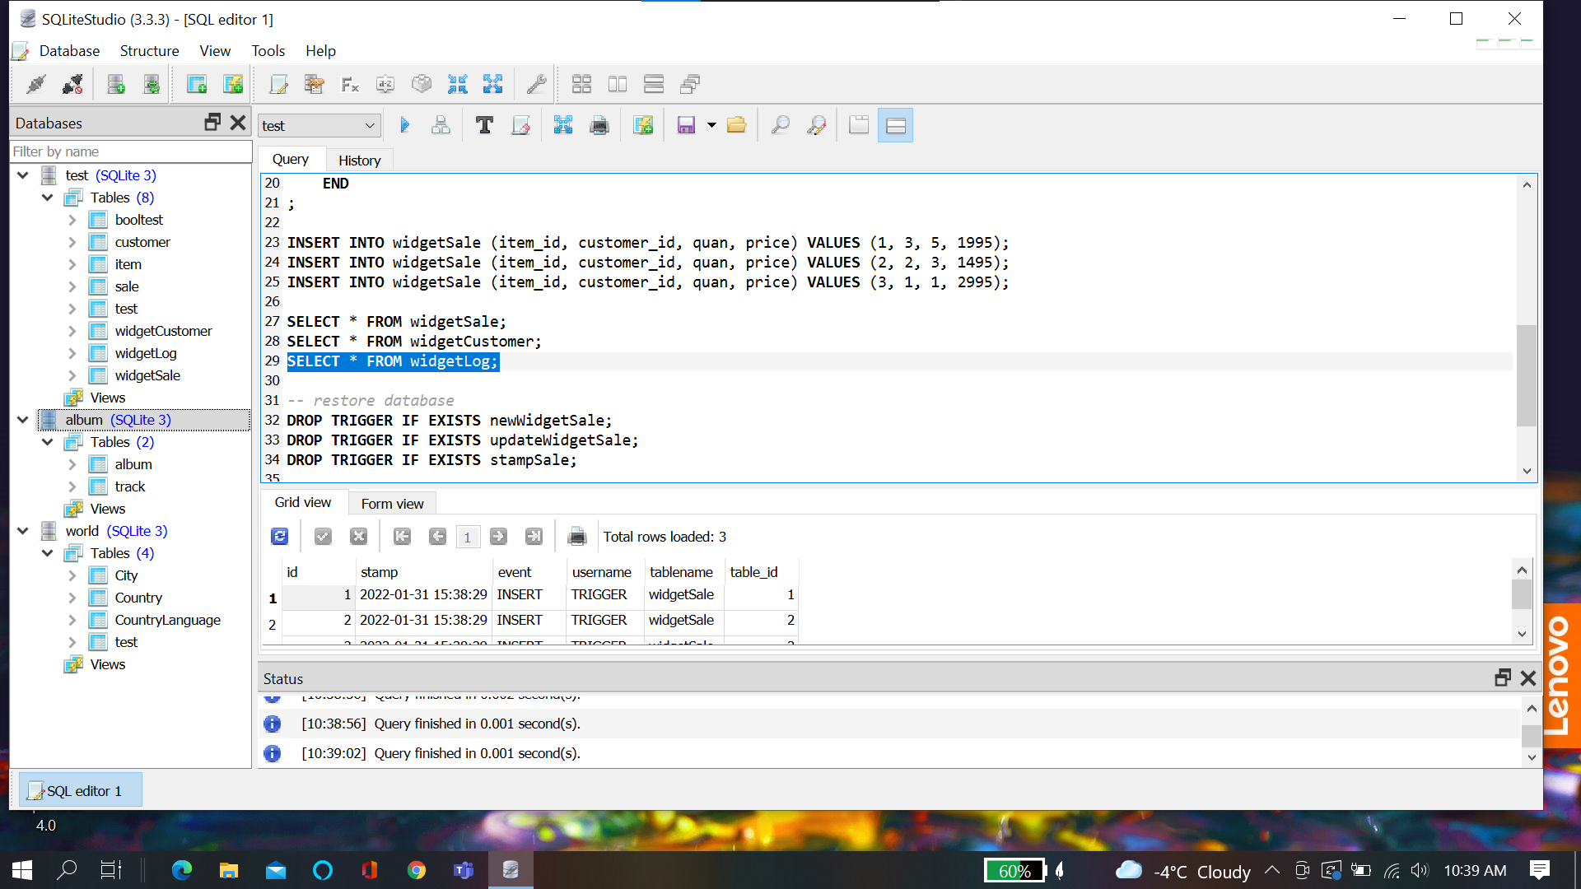

**Chapter Quiz:**

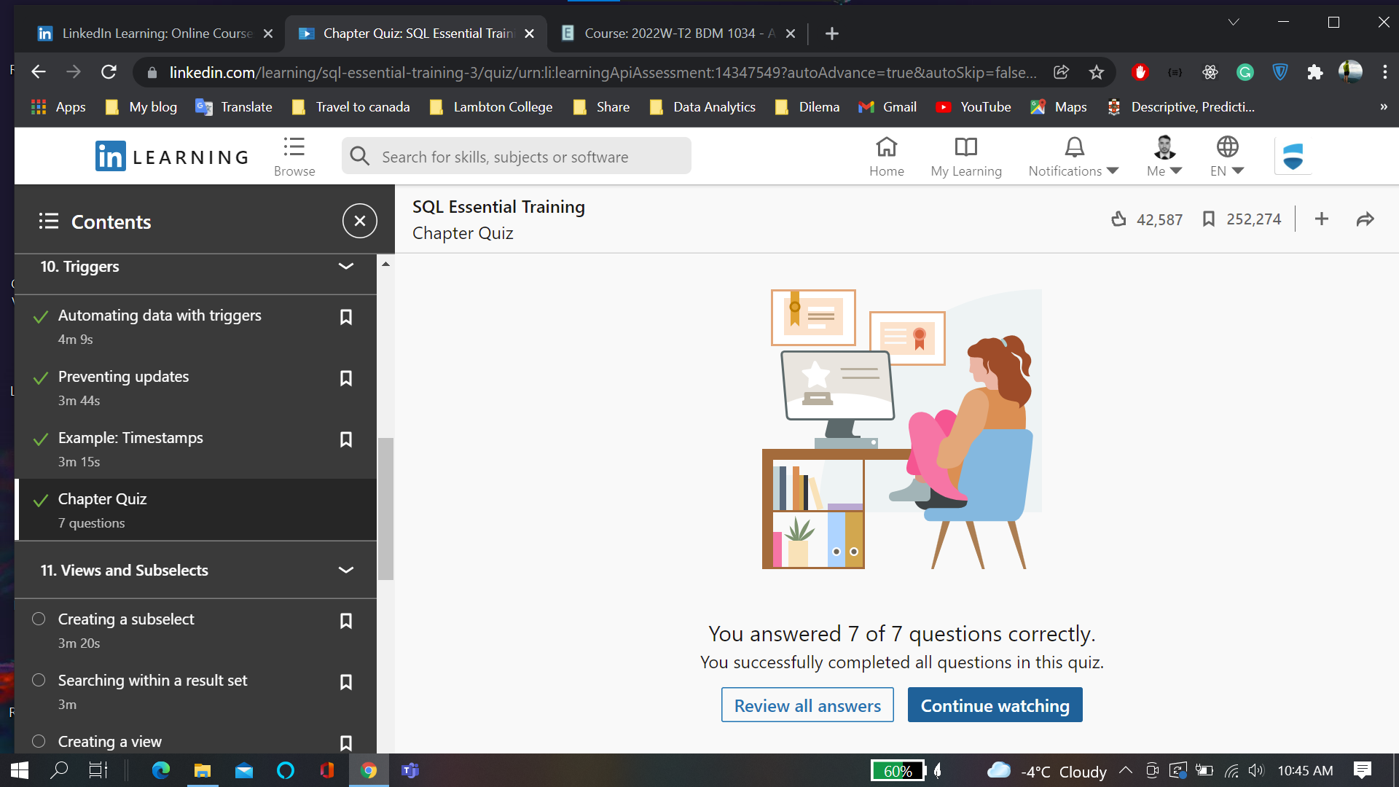

**Subselect:**

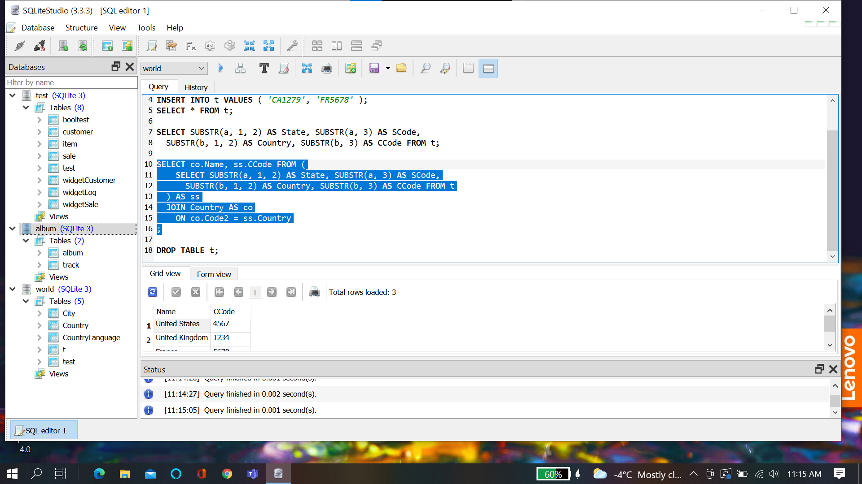

**Searching within resultset:**

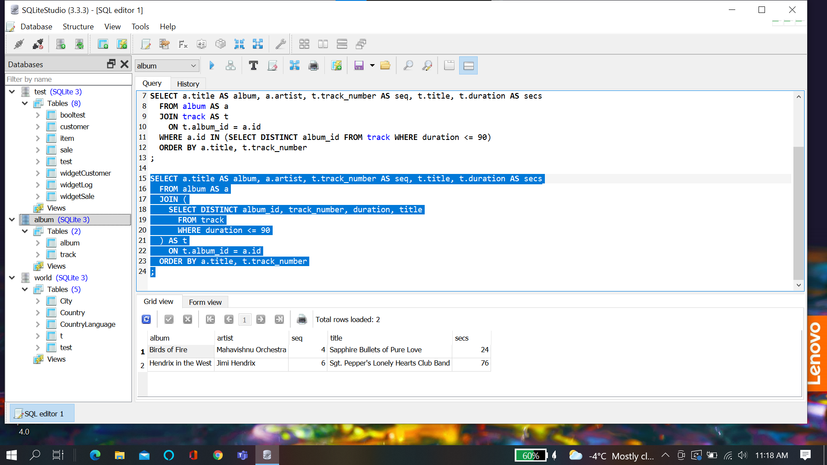

**View:**

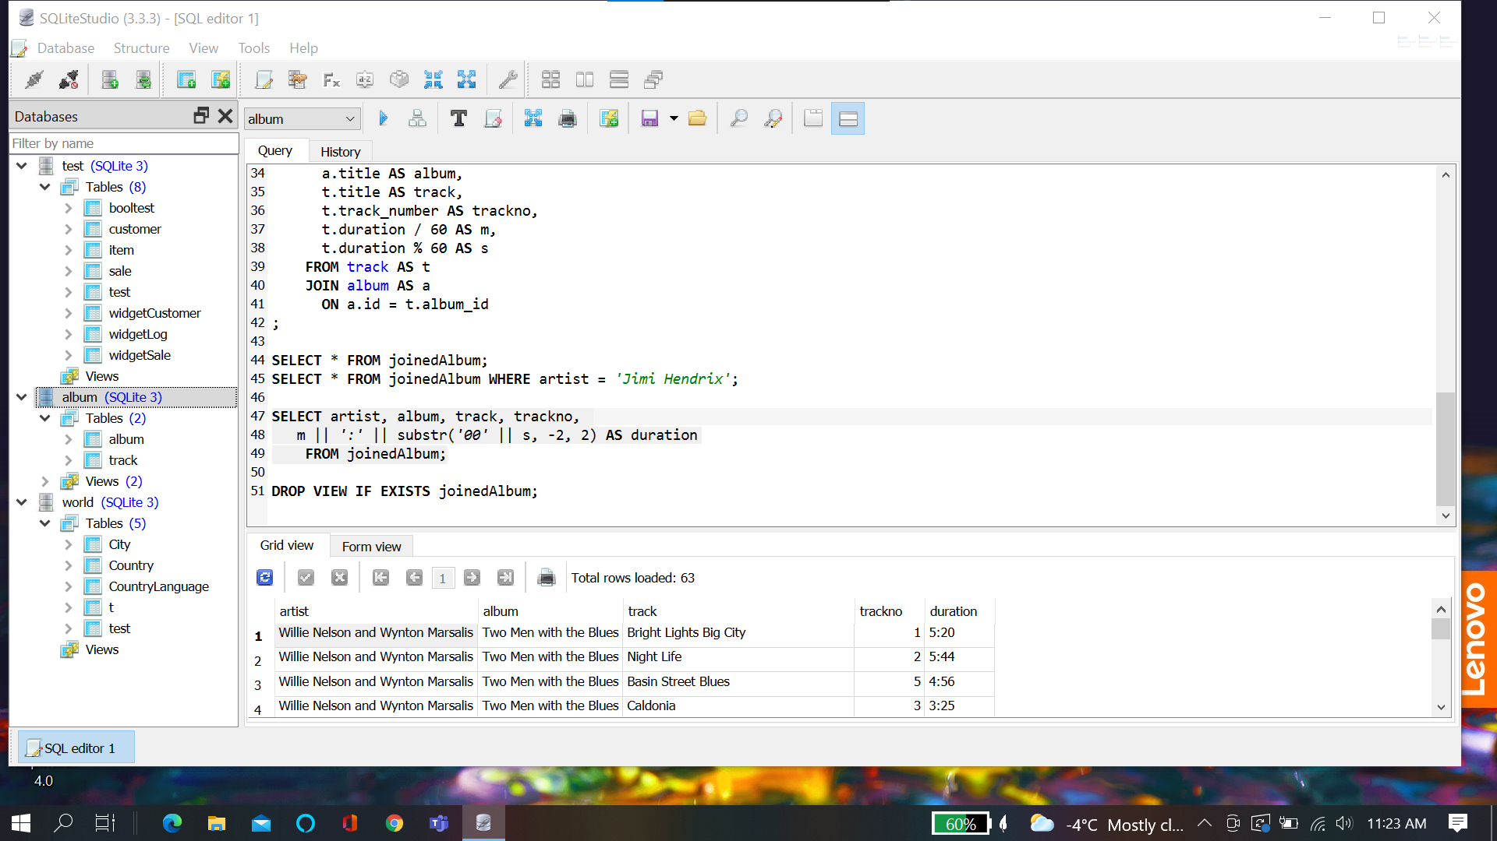

**Chapter quiz:**

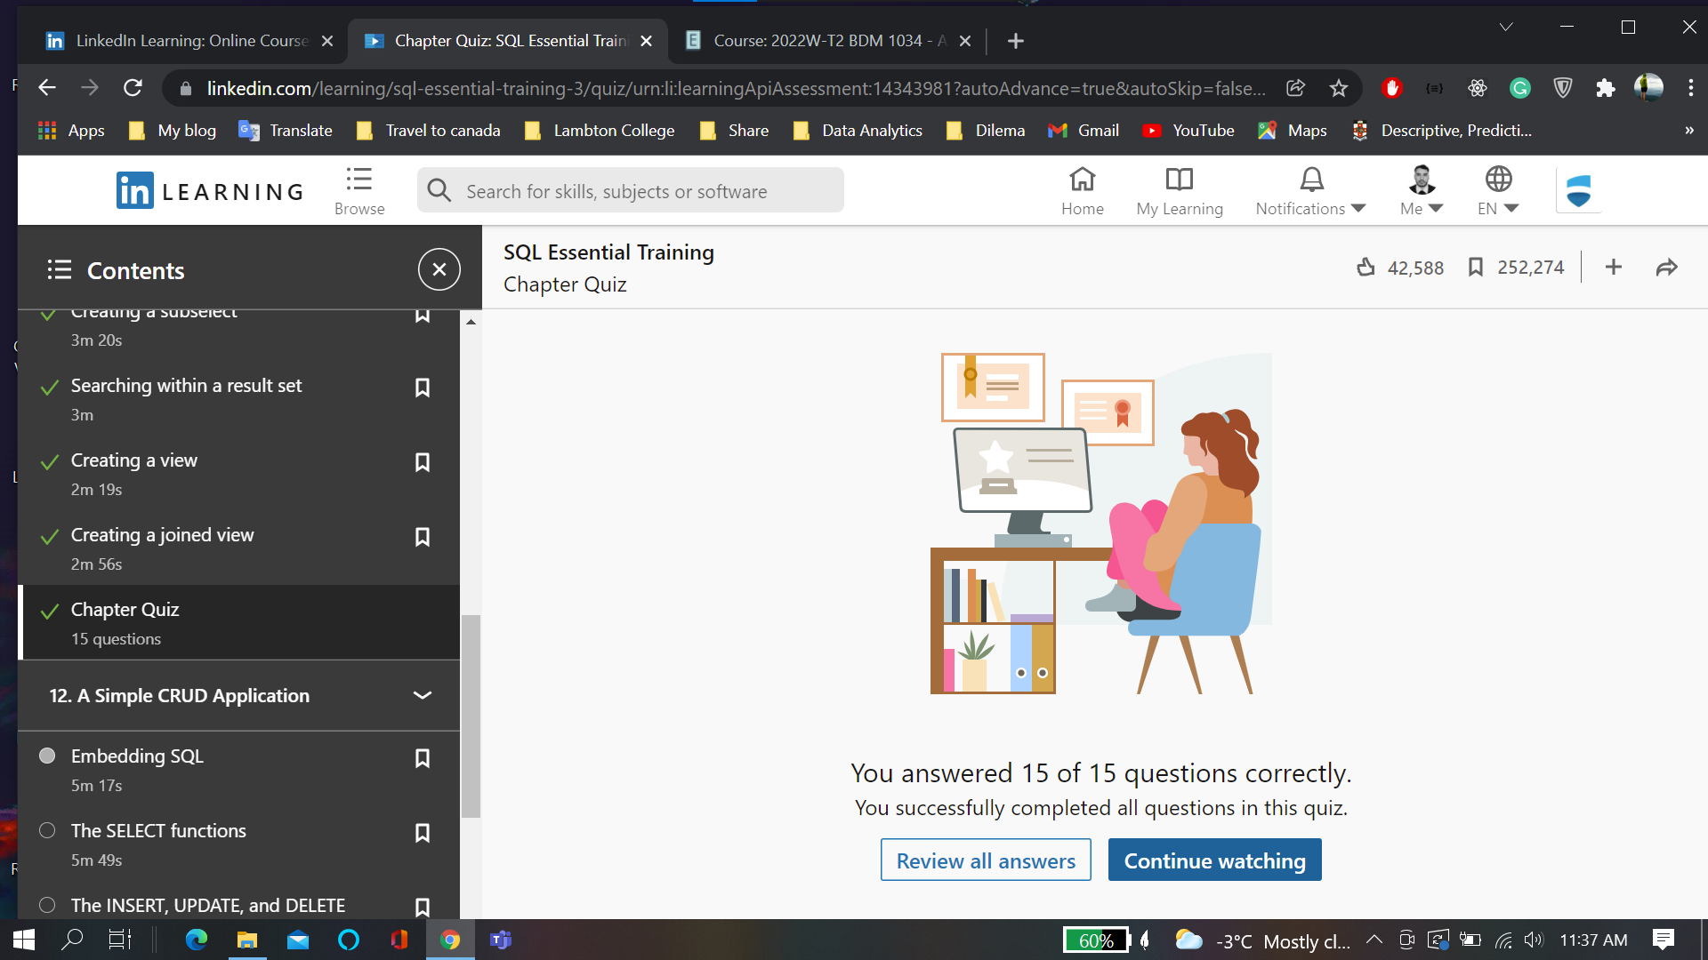

**CRUD Application:**

**Chapter quiz:**

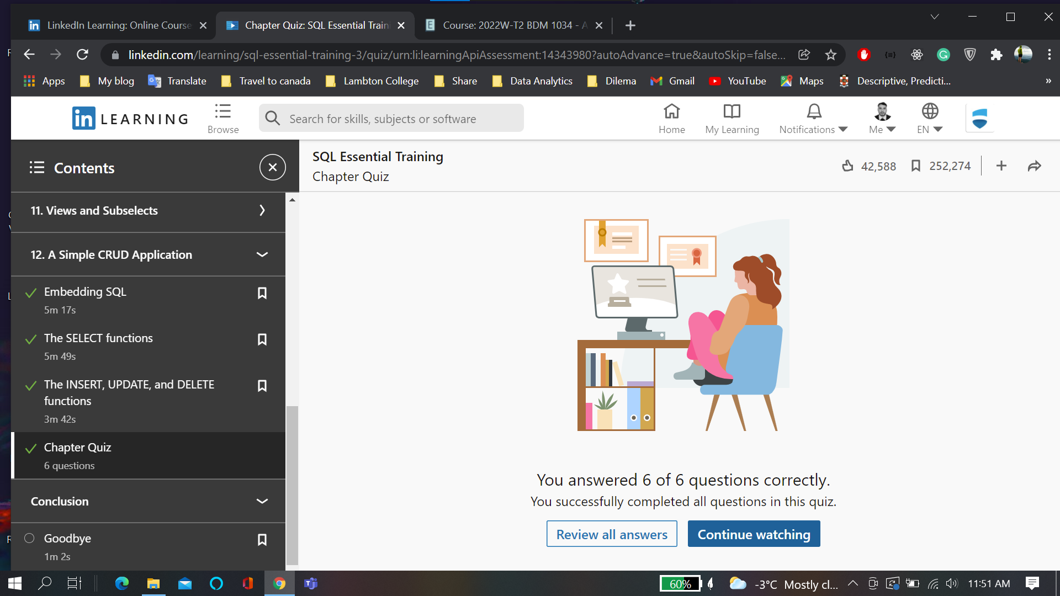

**Cerificate:**

